**1.Record script by using Normal Recording mode:**

Before recording the script need to identify scenario that need to be automated.

Select login functionality of Flight Reservation application.

Steps for Login:

**1)** Enter Valid Agent Name in Agent name field

**2)** Enter Valid Password in Password field

**3)** Press Ok button

**4)** Close Application after Successful Login

Let’s start recording

Before going to start recording open flight application

Start🡪All programs🡪Quick test professional🡪Sample application🡪Flight

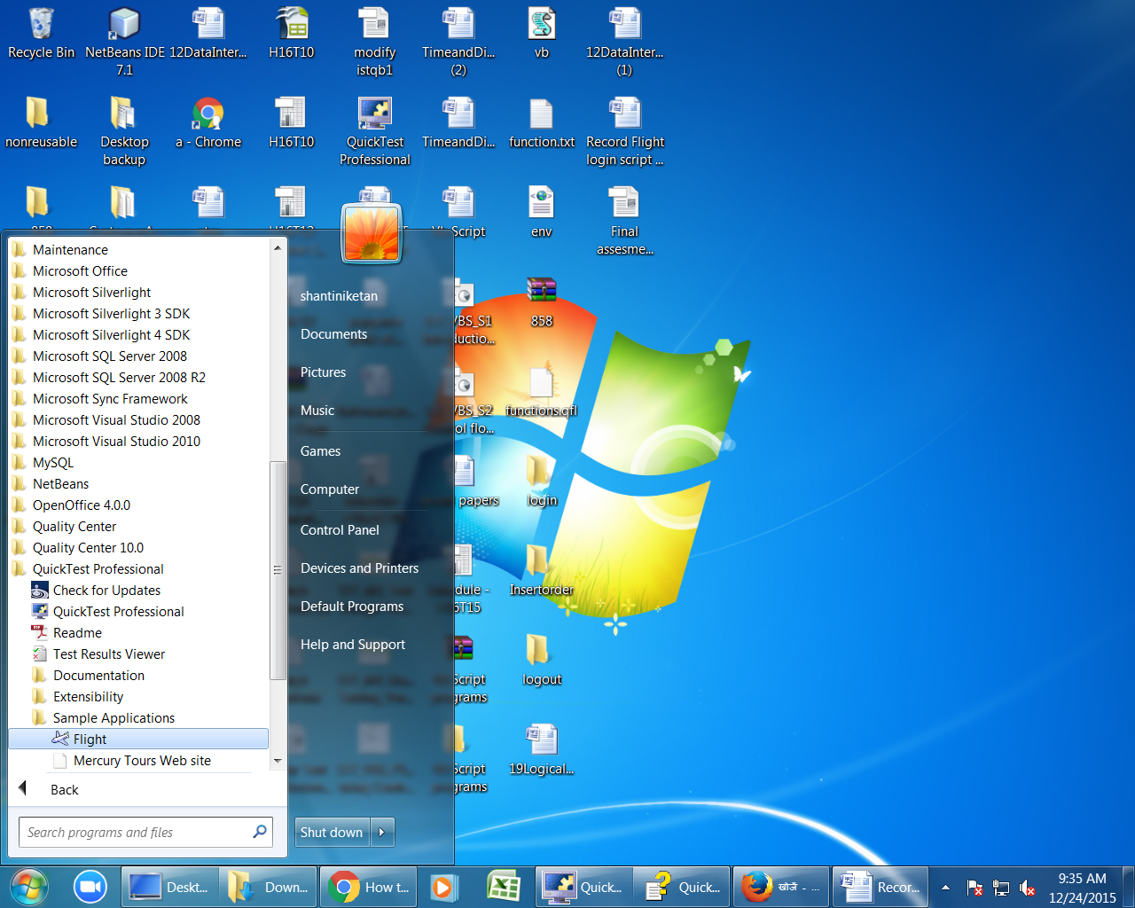

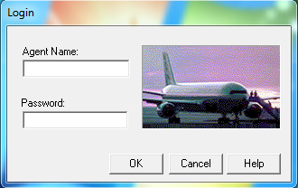

Open quick test Start🡪All programs🡪Quick test professional🡪

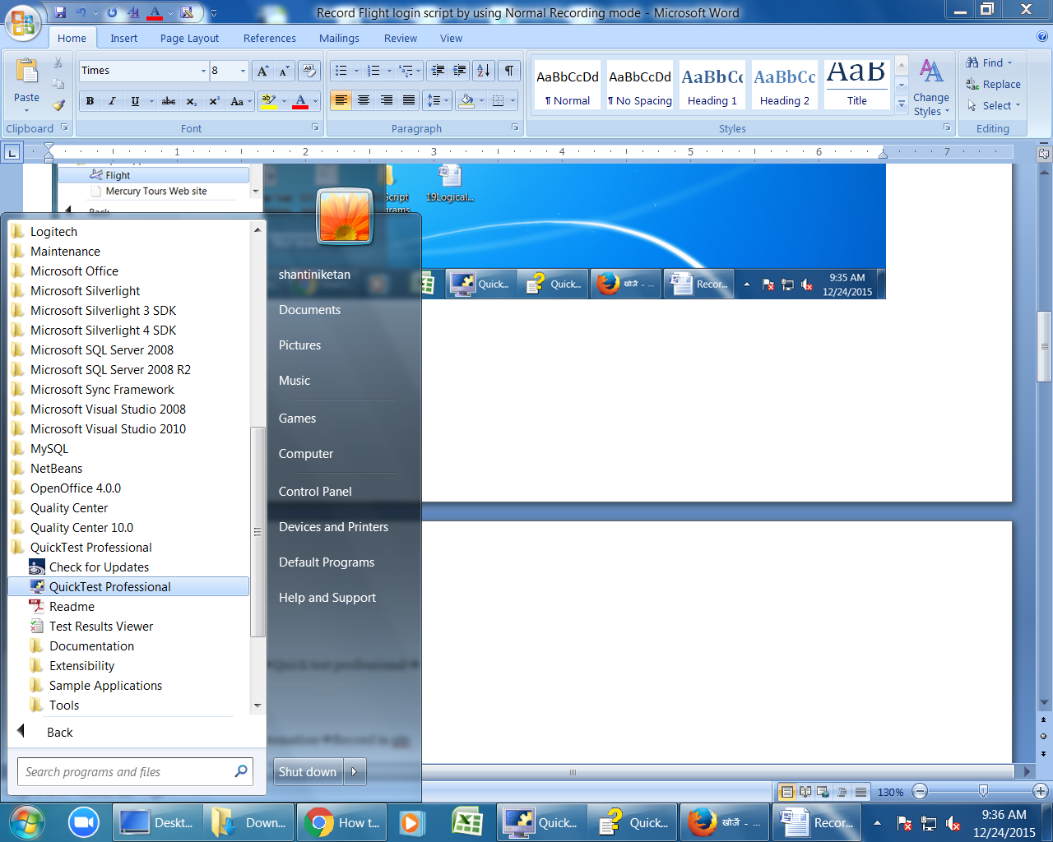

click on “record” button or (F3) or Automation🡪Record in qtp

The Record & Run settings Dialog Box Opens.

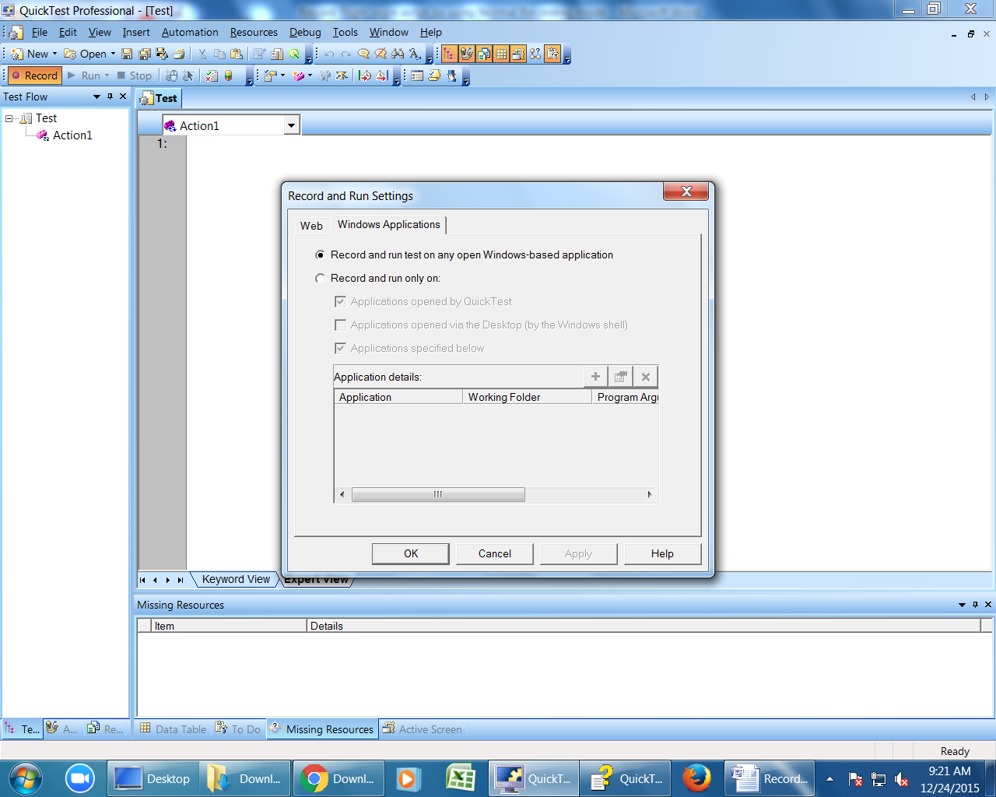

Select windows tab & It contains 2 options.

1) Record & Run on any open window based application

2)Record & Run on a specific window

By default first option will be selected.

Click ok button (qtp starts recording)

1.Enter Agent Name as “ramesh” in flight login window

2.Enter password as "mercury"

3. Click on "OK"

4. Close flight Reservation window.

Click on "Stop" button or press "F4" to stop recording.

To save test click the save button or select file🡪save

Then you can see below script generated in "Expert View" in QTP

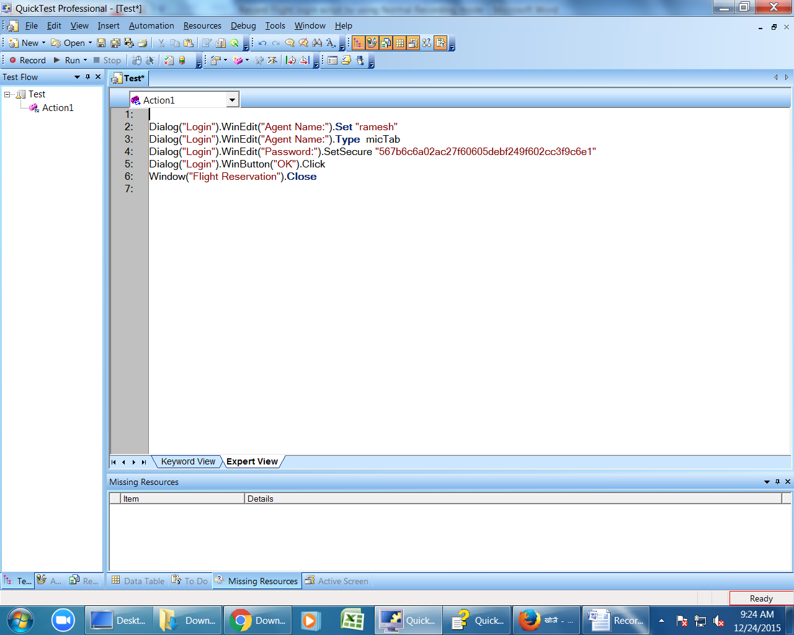

**2.Record Flight login script by using Analog Recording mode:**

**To record flight login functionality in Analog Recording mode**:

Before going to start Analog recording open flight application

Start🡪All programs🡪Quick test professional🡪Sample application🡪Flight





Open quick test Start🡪All programs🡪Quick test professional🡪



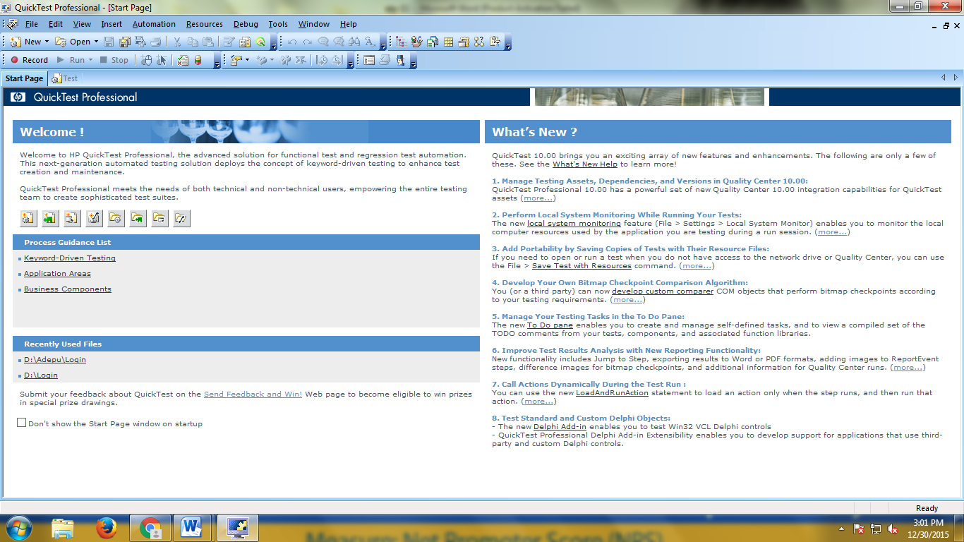

Open new test

File🡪new🡪Test and

click on “record” button or (F3) or Automation🡪Record in qtp

The Record & Run settings Dialog Box Opens.



Select windows tab & It contains 2 options.

1) Record & Run on any open window based application

2)Record & Run on a specific window

By default first option will be selected.

Click ok button (qtp starts recording)

Click the **Analog Recording** button or select **Automation > Analog Recording**.

The Analog Recording Settings dialog box opens.

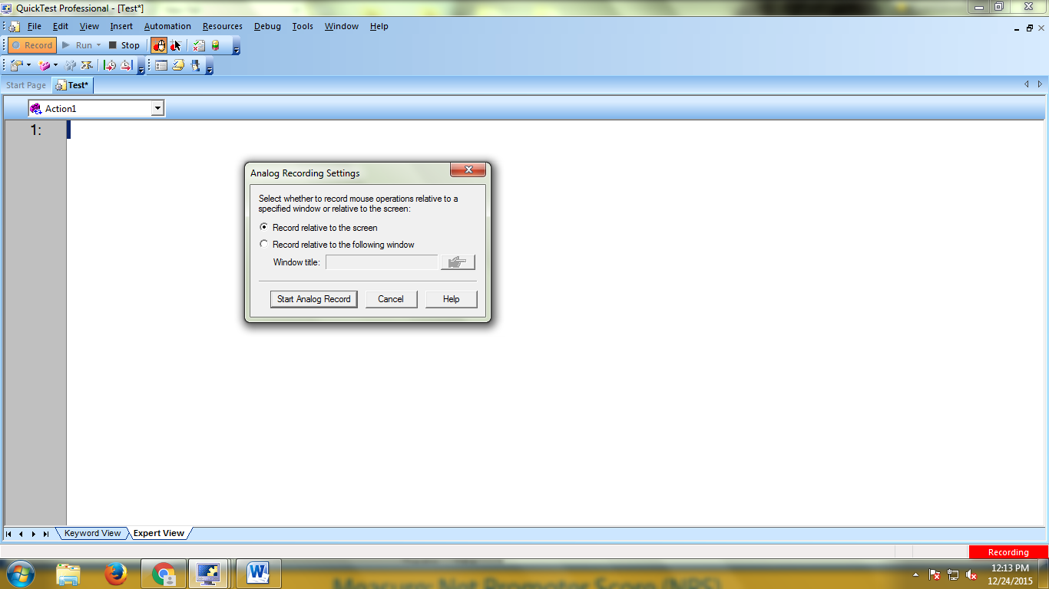

Select first option (Record relative to the screen)

Click on “Start Analog Record” button

Enter Agent name

Enter password

Click on ok

Close the flight reservation window in flight application

When you are finished and want to return to normal recording mode, click the **Analog Recording** button or select **Automation > Analog Recording** to turn off the option.

Quick Test inserts the **Run Analog** step in expert view in test pane

For example:

Desktop.RunAnalog "Track1"

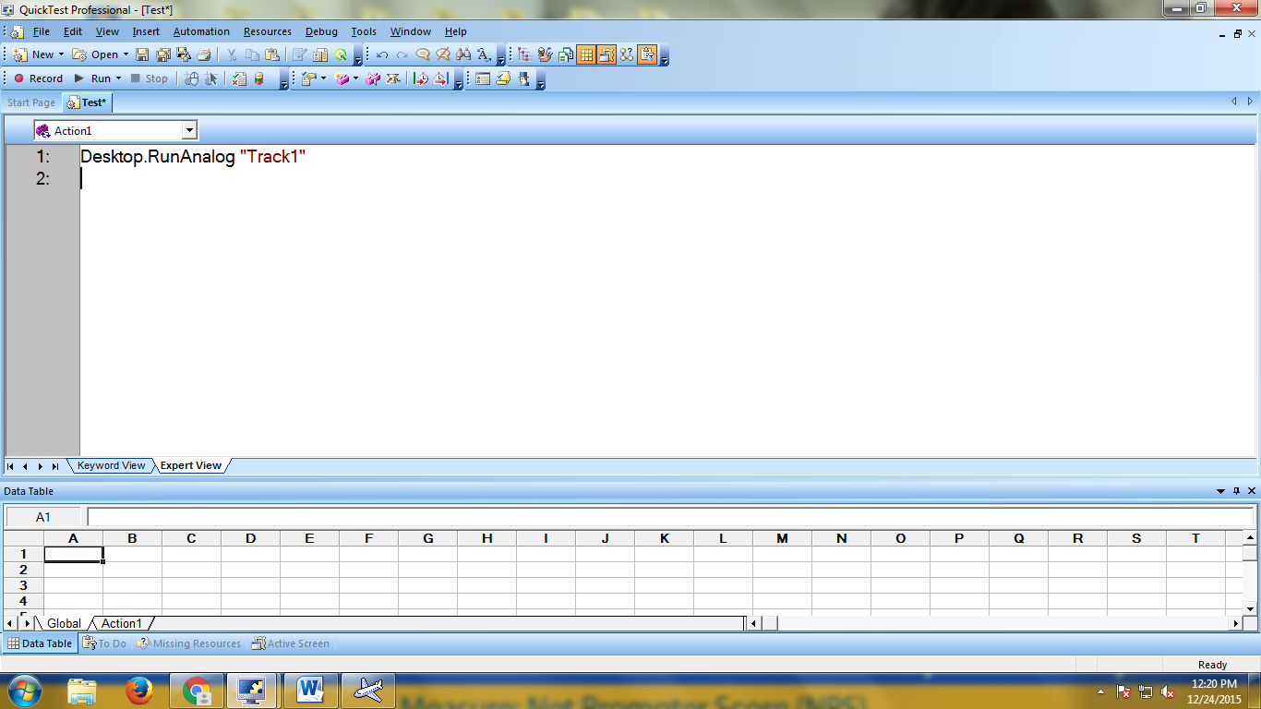

**3.Record flight login script by Using Low level Recording:**

**To record flight login functionality in Low level recording mode**:

Open flight login window

Start🡪All programs🡪Quick test professional🡪Sample application🡪Flight





Open quick test Start🡪All programs🡪Quick test professional🡪





Open new test

File🡪new🡪Test and

click on “record” button or (F3) or Automation🡪Record in qtp

The Record & Run settings Dialog Box Opens.



Select windows tab & It contains 2 options.

1) Record & Run on any open window based application

2)Record & Run on a specific window

By default first option will be selected.

Click ok button (qtp starts recording)

Click the **Record** button to begin a recording session

Click the **Low Level Recording** button or select **Automation > Low Level Recording**.

(The record mode changes to **Low Level Recording** )

1.Enter Agent Name as “ramesh” in flight login window

2.Enter password as "mercury"

3. Click on "OK"

4. Close flight Reservation window.

Click on "Stop" button or press "F4" to stop recording.

Quick Test inserts the **Low level recording** step in expert view in test pane

For example:

